Joshua Catoe

CSCI 473

2/8/20

MPI02 – Report

**Screenshots**

Compilation of program

Program running on two processes

Program running on four processes

Program running on sixteen processes

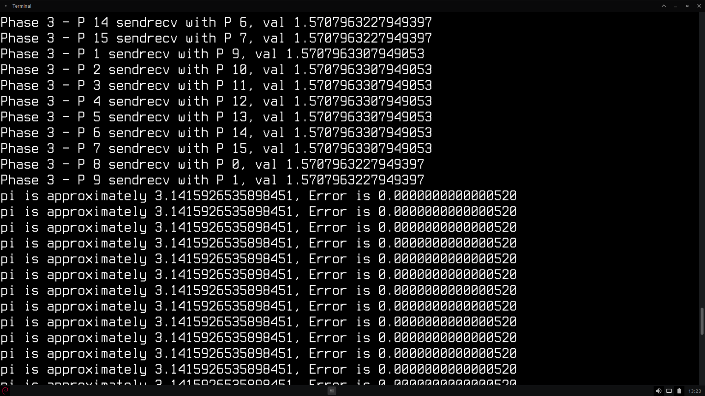

Program exiting with usage statement when number of processes is not a power of two

